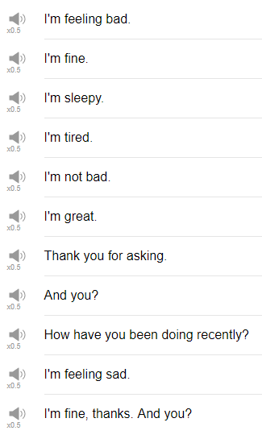

|  |
| --- |
| Want to speak real English from your first lesson? Sign up for your free lifetime account at EnglishClass101.com! |
| Hi, everybody! Welcome back to Top Words! My name is Alisha, and today we're going to be talking about 10 different phrases that you can use to respond to the question "how are you?" So let's go! |
| 1. I’m great. |
| The first phrase is "I'm great". if someone says "how are you?" you can say "I'm great!" Try to say I'm great with a kind of an upbeat voice, so something like "how are you?" "I'm great." |
| 2. I'm feeling bad. |
| If you say "I'm feeling bad", the other person is probably, if they're friend of yours, or co-worker, going to ask you "why? What happened?" So if you want to use "I'm feeling bad" make sure you have an explanation ready. Anyway, somebody says "how are you?" and you go, I'm feeling bad, maybe, I went out for drinks last night with my coworkers. Oops! |
| 3. I'm okay. I'm okay. |
| I feel like this is one of those intonation practice ones. I'm okay, with that I'm okay, like, sort of upward intonation, you're like cool, but if someone says "how are you" "I'm okay..." They'll be like "oh, no! What happened?" So you can use your intonation with I'm okay to make it a good thing, or a not so good thing, but either way it's not like a very super serious response. |
| 4. Thank you for asking. |
| And yeah, I imagine this would be in a more formal situation, if my friend said to me "how are you?" and I was like thank you for asking, they'd be like "what?" I would say "I'm fine" or "I'm doing well". I'm doing great. Plus "thank you for asking", so "how are you?" I'm doing very well, thank you. That's how I would use it. |
| 5. And you? |
| The next one is "and you?" like, the least natural response to "how are you" is "I'm fine, thank you, and you?" like, just get out of, just take it out of your head. Nobody says that, I always say "how about you?" that's a much more natural thing. |
| 6. How are you? |
| How are you? can be a response again after you have given your answer to the question. "How are you?" “I’m great. How are you?” "How are you? I'm good, how are you?" "I'm great, how are you?" “I’m okay, how are you?“ |
| 7. How have you been recently? |
| This is only useful if you haven't seen the other person for a while. |
| 8. I'm not bad. |
| How are you? I'm not bad. I'm not bad, things could be worse. I would probably do this, "I'm not bad". |
| 9. I'm sleepy. |
| The next expression is "I'm sleepy". It's, like, so specific, someone said How are you? I would probably say "I'm okay, but i'm a little sleepy." I don't know that I would just say "I'm sleepy" unless it's a really good friend of mine. It's a person close to you, you can say I'm so tired, I'm, I would say, "I'm super tired" or "I'm really tired", and I feel like that's a little bit more natural than just "I'm sleepy". |
| 10. I'm good. |
| One that I use a lot, if someone says "how are you?" I say "I'm good." That's just probably my go-to response, yeah. I'm good, I'm good, maybe I'll repeat it while smiling. I'm good, I'm good, yeah, thanks for asking. |
| That is the end! Those are 10 phrases that you can use to respond to the question "how are you?" If there's one takeaway from this, and from other things that we've done over the last few years in this channel, just get rid of that "I'm fine, thank you, and you?" and pick one of these that we've talked about today. Of course, if there's another expression that you use for a response to "how are you?" I'd be very interested to learn about that, but in general you're pretty safe if you stick with these. So thanks very much for watching this episode of Top Words and we will see you again soon. Bye! |